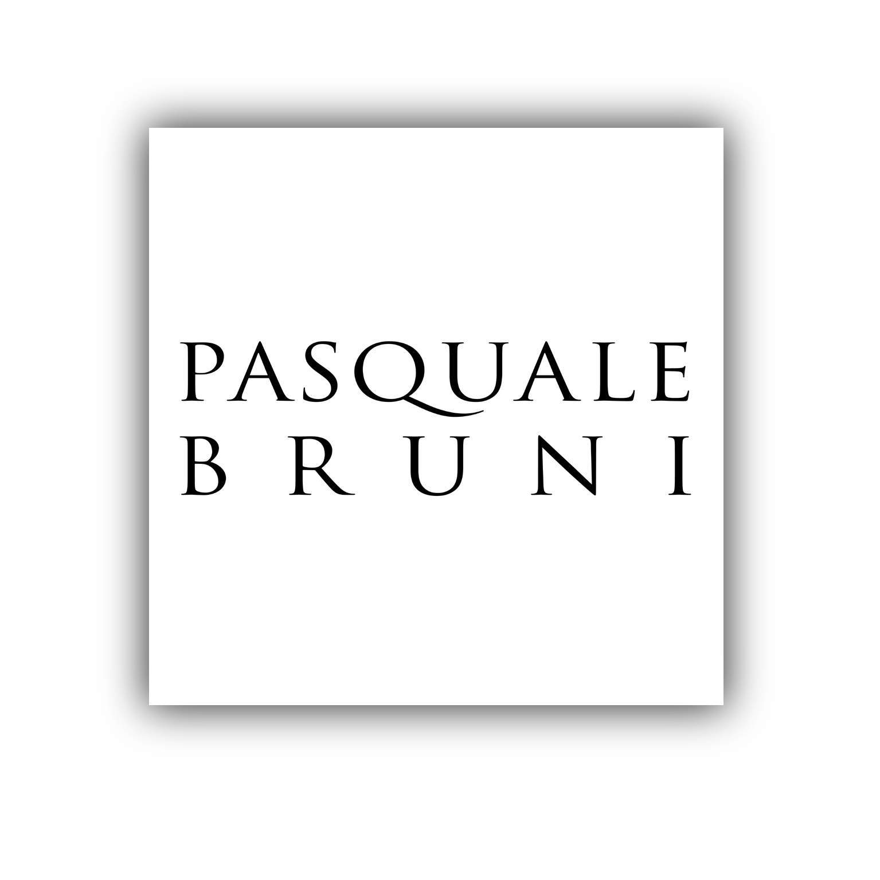

EUGENIA BRUNI

Notes of femininity, sensuousness and freshness in her creations

Eugenia Bruni was born in Valenza Po, a world-famous jewellery design and production centre, the ideal place for learning the secrets of the goldsmith’s art.

She inherited her creative instinct, passion for jewellery and artistic genius from her father, with whom she pursues a very prolific artistic relationship.

She started visiting the goldsmiths’ workshops in Valenza when she was just a little girl quickly acquiring a passion for her father’s work and grew up in the sparkling, creative atmosphere of his firm.
It was indeed in Valenza, and assisted by Pasquale, that Eugenia took her first steps in the world of jewellery and quickly revealed a very feminine instinct and creative vein.

After finishing her art studies and working as a designer in the company she spent three years in the United States; New York, Los Angeles and San Diego - absorbing new artistic and cultural experiences. Her stay in America broadened her expertise and enhanced her talents.

Upon her return to Italy and her father’s firm, she became the brand’s artistic director, introducing new ideas and fresh creativity.

Now in the role of Creative Director, Eugenia divides her time between the production unit in Valenza and the Milan showroom coordinating corporate image, handling press relations and taking part in the major trade fairs.

Eugenia’s creations are inspired by nature: the light of day and dark of night, morning dew, the warmth of the sun. Under her creative guidance, gold, diamonds and colour stones are transformed in delicate garlands of flowers, sensuous enchanted branches, exotic dewdrops, sparkling stars exuding the very essence of nature and a passion for beauty.

Her research is also directed toward the study and use of stones in innovative cuts expressly designed to enhance an undoubtedly contemporary design which complements the more classic designs of her father.

While constantly paying attention to what women want, Eugenia has succeeded in extending the creative strength of Pasquale Bruni jewellery by designing collections that come to life against the skin of whomever wears them, enhancing feminine allure.

